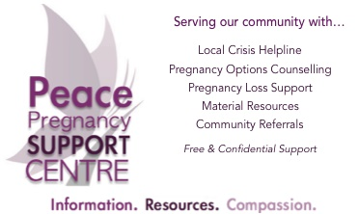
Jan 25, 2023
The Peace Pregnancy Support Centre (PPSC) of Dawson Creek, BC is looking for an Executive Director (ED) whose primary role will be to assist the board in re-opening our Centre and to lead the operations toward fulfilling our mission and vision. We are looking for a Christian individual whose counseling-based education and / or experience, and mature faith would allow her to guide our Centre in delivering quality services and support to our clients, recruiting and managing staff and volunteers, promoting our agency to the community, building our donor base, and working cooperatively with the Board. We are seeking someone with a missions-focused heart.
This is a part-time permanent position - with the potential for full-time placement. The individual winning the position may start as soon as possible, and will be provided Director Accreditation Training (DAT) through Pregnancy Care Canada (PCC).
The PPSC is a faith-based non-profit organization. We provide non-judgmental, compassionate support and information on all pregnancy options to anyone regardless of their religious beliefs, lifestyle, gender identification, sexual orientation, or any other arbitrary circumstance.
We follow a respectful, client-led, permission-based approach, providing safe and compassionate emotional & spiritual support along with practical assistance, empowering clients to have choice and control over their lives.
Our work environment includes:
- Relaxed atmosphere
- Growth opportunities
- Flexible working hours
Please contact us for a detailed job description and application package.
250-782-5642
info@peacepregnancysupport.com or dclh.ppss@outlook.com
APPLY NOW!

